**A Precision Agriculture Technique for Optimum Irrigation in Tomato Plant**

Pritam

Gurung

(

030)

PAS075BGE

Roshan

Kafle

PAS075BGE

(

033

)

Samir

Pahari (PAS075BGE035)

Sujan

Adhikari

(

043

PAS075BGE

)

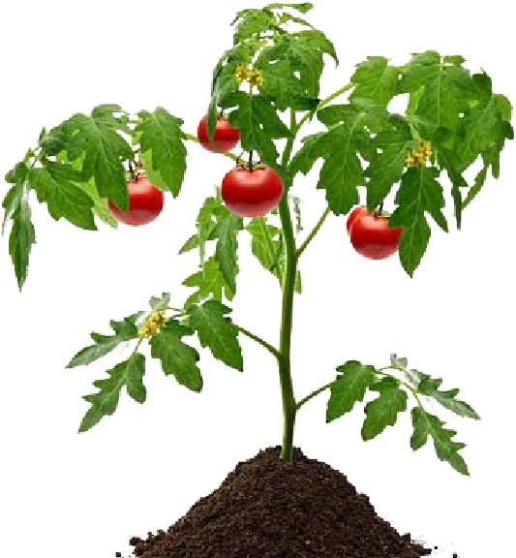

**To identify the suitable amount of**

**Water or**

**moisture for high**

**productivity of tomato.**

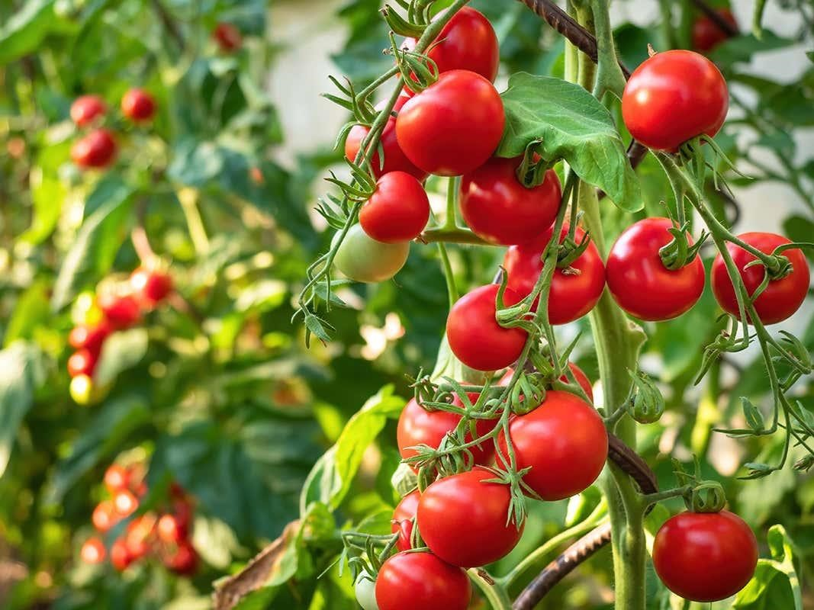

**OBJECTIVES**

**STUDY AREA**

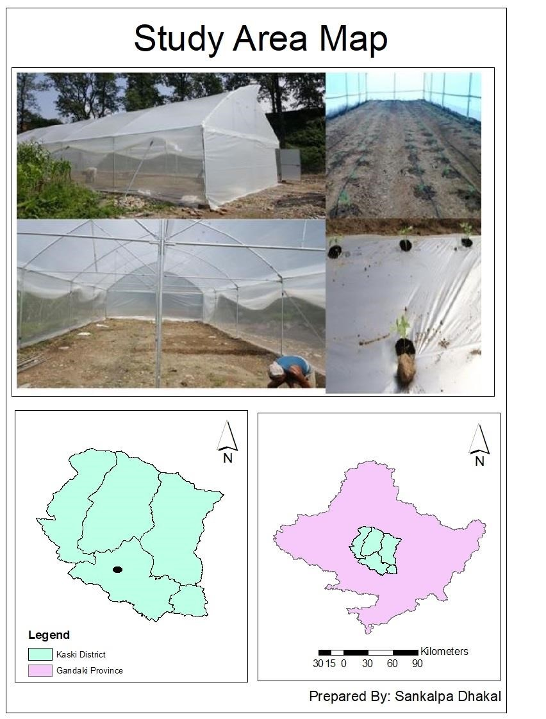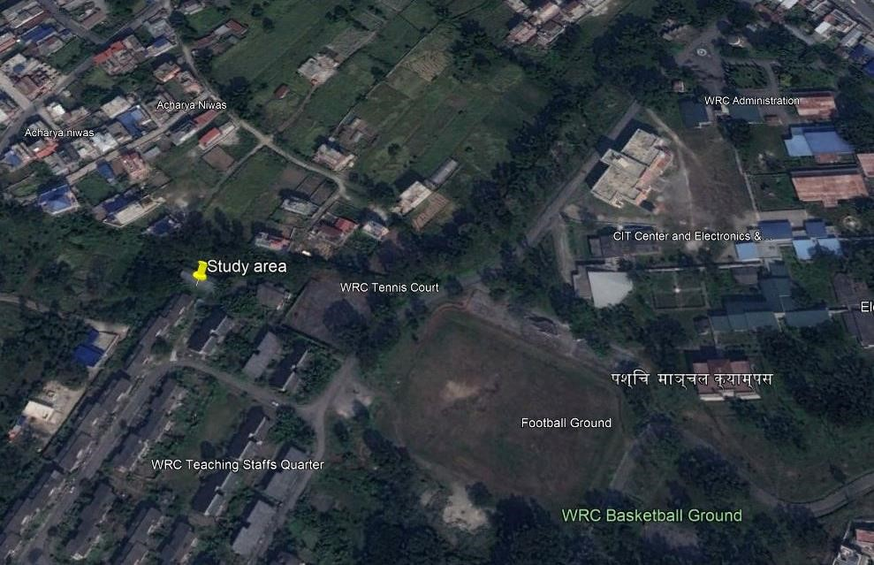

# METHODOLOGY

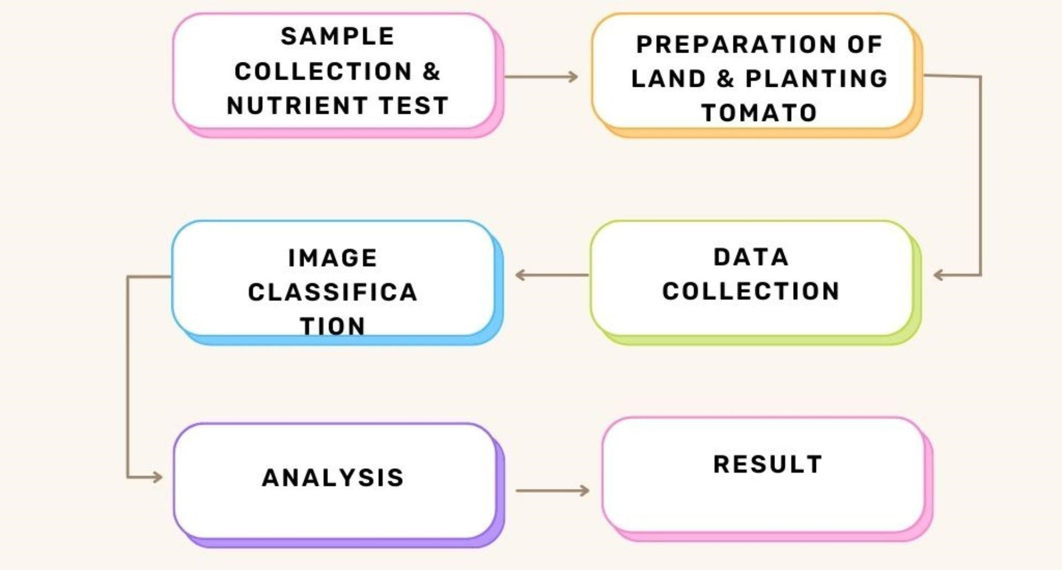

## Soil Sample Collection

* Using handheld auger
* From top soil
* From five different parts

on the field

## Soil Nutrition test

|  |  |  |  |
| --- | --- | --- | --- |
| **pH value**  **Normal = 7.1** | **Nitrogen (%)**  **Less= 0.04** | **Phosphorus (kg/hec)**  **Medium = 31.98** | **Potassium (kg/hec)**  **Medium = 139.92** |

**Table : Nutrient status of soil sample.**

## Preparation of land

* 150kg of FYM was added along with 9.518kg urea,

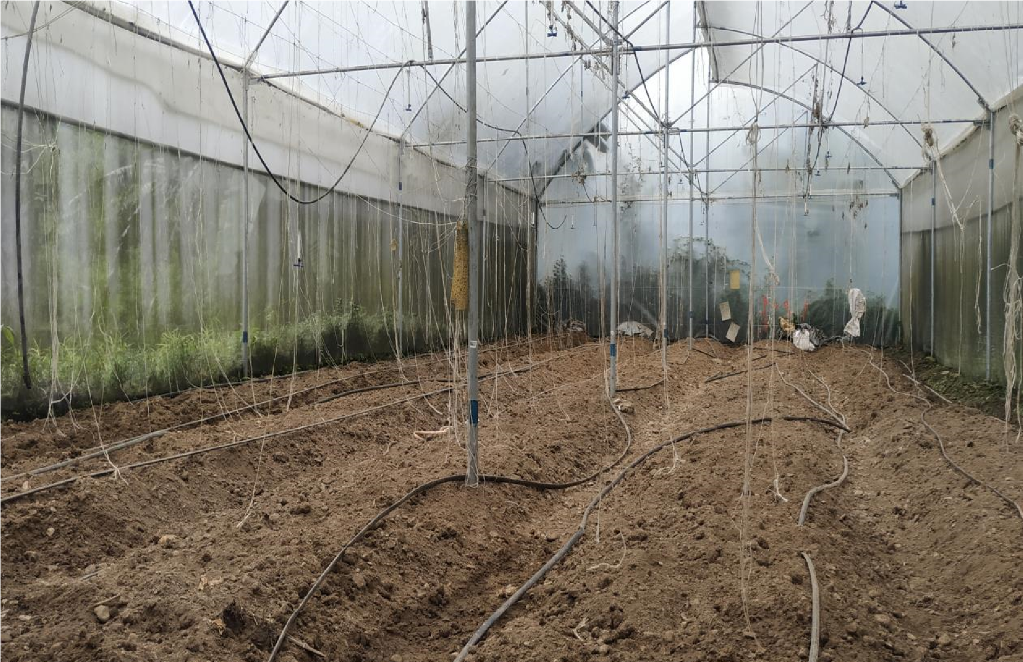2.68kg DAP and 3.17kg MOP.

* Total 5 Plots each contains 3 subplots. (5*3 = 15 subplots)

## Irrigation

* Divided into different plot 25%, 50%, 75% and 100% field capacity.

# Data Collection

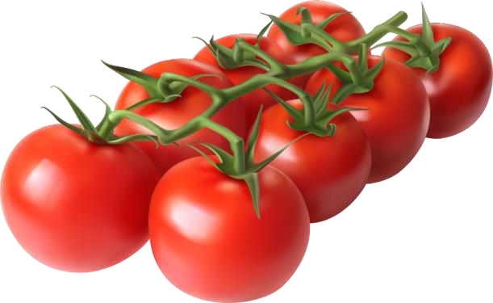

**Image Capturing Soil Moisture**

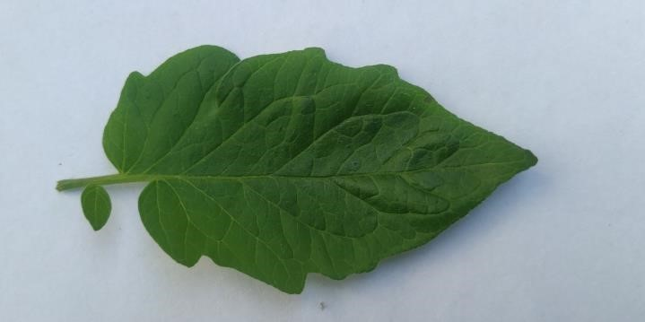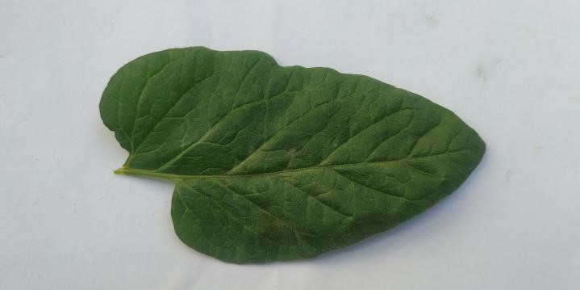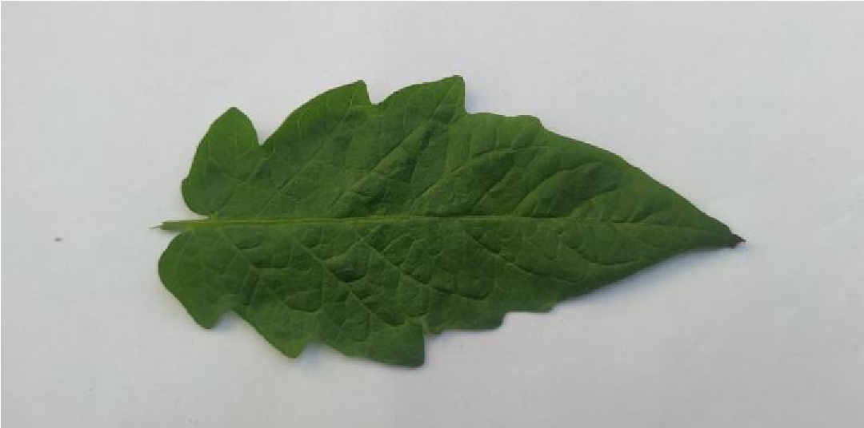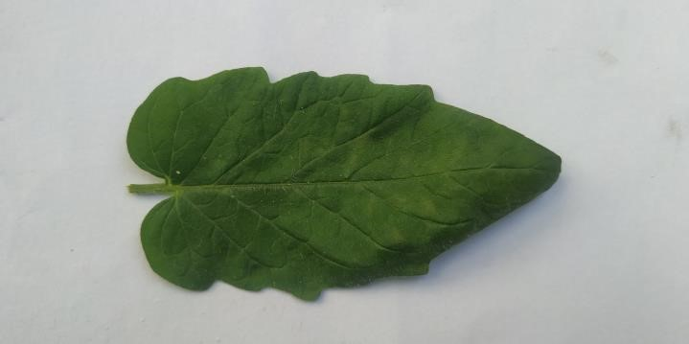

**Table : Moisture Data**

|  |  |  |  |  |  |  |  |  |  |  |  |  |  |  |  |
| --- | --- | --- | --- | --- | --- | --- | --- | --- | --- | --- | --- | --- | --- | --- | --- |
| Date | Plot A | Plot B | Plot C | Plot D | Plot E | Plot F | Plot G | Plot H | Plot I | Plot J | Plot K | Plot L | Plot M | Plot N | Plot O |
| 4/30/2079 | 18.7 | 22.4 | 16.6 | 19.5 | 24.7 | 14.4 | 15.4 | 20.2 | 18.6 | 13.1 | 17.2 | 10.3 | 23.1 | 25.2 | 18.5 |
| 5/8/2079 | 22.3 | 23.1 | 18.5 | 22.7 | 29.3 | 15.3 | 19.7 | 24.6 | 24.3 | 22.5 | 19 | 14.9 | 13.8 | 22.4 | 18.7 |
| 5/23/2079 | 16.6 | 18.8 | 21.2 | 14.7 | 13.8 | 9.9 | 12.9 | 20.5 | 13.9 | 12.6 | 22.4 | 20.3 | 16.3 | 11.1 | 20.2 |
| 6/2/2079 | 10.5 | 16.8 | 15.7 | 13.5 | 24.5 | 10.6 | 11.9 | 20.2 | 9 | 23.1 | 23.7 | 21.5 | 12.8 | 14.4 | 22.6 |
| 6/13/2079 | 15.5 | 20.3 | 19 | 17 | 20.3 | 12.9 | 17.3 | 18.4 | 13.8 | 16.4 | 13.4 | 20.5 | 11.5 | 14.6 | 19.7 |
| 6/27/2079 | 28.1 | 23.3 | 18 | 21.5 | 21.4 | 14.6 | 24 | 14 | 16.9 | 12.4 | 13.4 | 22.4 | 7.1 | 9.2 | 22.4 |
| 7/6/2079 | 16.6 | 18.8 | 21.2 | 14.7 | 13.8 | 9.9 | 12.9 | 20.5 | 13.9 | 12.6 | 22.4 | 20.3 | 16.3 | 11.1 | 20.2 |
| 7/14/2079 | 18.7 | 16.8 | 15.7 | 13.5 | 24.5 | 10.6 | 11.9 | 20.2 | 9 | 23.1 | 23.7 | 21.5 | 12.8 | 14.4 | 22.6 |
| 7/20/2079 | 20.2 | 23.1 | 20.3 | 16.3 | 11.1 | 15.3 | 19.7 | 24.6 | 29.3 | 22.5 | 19 | 14.9 | 13.8 | 22.4 | 18.7 |
| 7/30/2079 | 19.7 | 18.8 | 21.5 | 12.8 | 14.4 | 9.9 | 12.9 | 9.9 | 12.9 | 20.5 | 22.4 | 20.3 | 16.3 | 11.1 | 20.2 |
| 8/7/2079 | 15.5 | 20.3 | 7.1 | 17 | 20.3 | 12.9 | 17.3 | 18.4 | 24.5 | 16.4 | 13.4 | 20.5 | 11.5 | 14.6 | 19.7 |

|  |  |  |  |  |  |  |  |  |  |  |  |  |
| --- | --- | --- | --- | --- | --- | --- | --- | --- | --- | --- | --- | --- |
| **Date** | **Plot A** | **Plot B** | **Plot C** | **Plot D** | **Plot E** | **Plot F** | **Plot G** | **Plot H** | **Plot I** | **Plot J** | **Plot K** | **Plot L** |
| 6/29/2079 | 0.712 | 0.712 | 0.396 | 1.512 | 1.418 | 0.724 | 0.642 | 0.66 | 0.452 | 0.404 | 0.566 | 0.604 |
| 7/1/2079 | 0.76 | 1.478 | 1.29 | 2.654 | 2.654 | 1.48 | 0.438 | 1.316 | 1.884 | 0.896 | 2.502 | 0.752 |
| 7/5/2079 | 1.98 | 0.614 | 1.338 | 1.748 | 1.888 | 1.178 | 1.264 | 0.884 | 1.946 | 1.298 | 1.528 | 1.164 |
| 7/11/2079 | 1.556 | 2.216 | 2.636 | 5.443 | 3.646 | 3.556 | 2.558 | 2.78 | 1.484 | 1.894 | 1.814 | 1.946 |
| 7/15/2079 | 1.214 | 2.168 | 3.864 | 1.423 | 1.448 | 1.508 | 0.432 | 1.556 | 0.45 | 1.566 | 0.574 | 1.208 |
| 8/8/2079 | 1.86 | 1.29 | 0.498 | 0.934 | 1.838 | 0.288 | 1.186 | 1.888 | 0.15 | 1.864 | 0.62 | 0.428 |
| **Sum** | **8.082** | **8.478** | **10.022** | **13.714** | **12.892** | **8.734** | **6.52** | **9.084** | **6.366** | **7.922** | **7.604** | **6.102** |
|  |  | **100% Field Capacity** |  |  | **75% Field**  **Capacity** |  |  | **50% Field Capacity** |  |  | **25%**  **Field**  **Capacity** |  |

## Fruit yield

**DATA ARRANGEMENT**

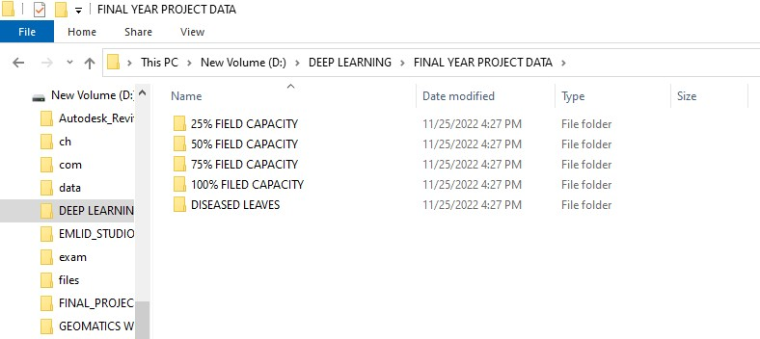

Train Test Split

Model Building

Processing

Post

-

Processing

Pre

-

Processing

Resizing and

Rescaling

Data

Augmentation

Prediction on Test

Data

Model Deployment

in Web Application

**Data Splitting**

Test Data

Model

Train Data

Predict

Function

## Pre - Processing

* 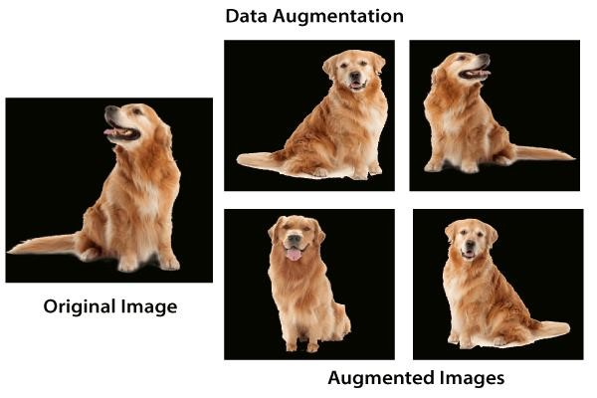RESIZING
* RESCALING • DATA AUGMENTATION

**CNN**

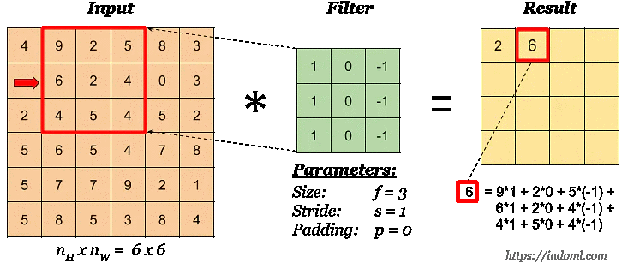

**Filter**

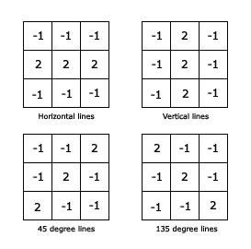

**Horizontal Filter**



**Transfer Learning**

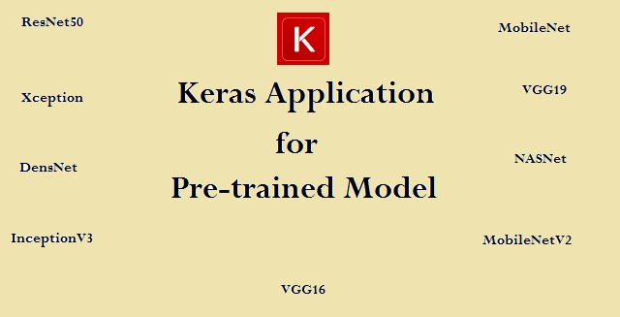

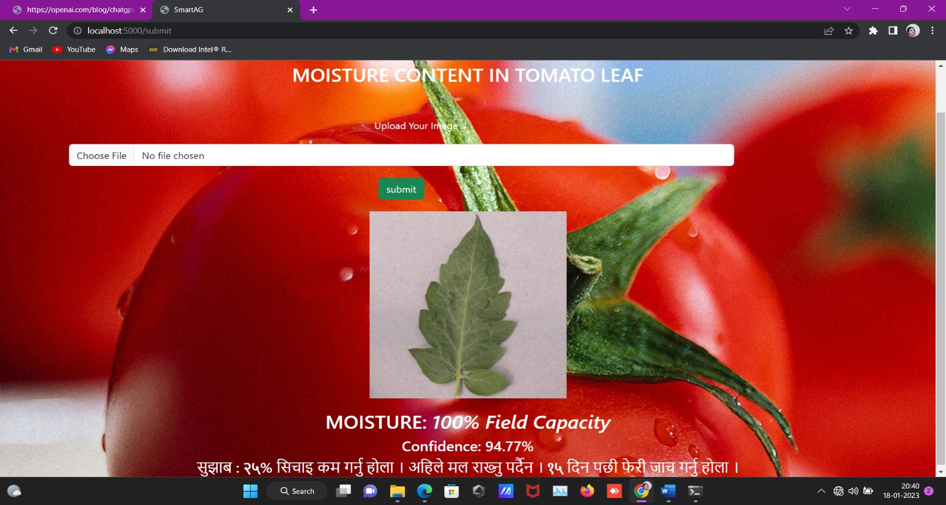**Web App**

**TIMELINE**

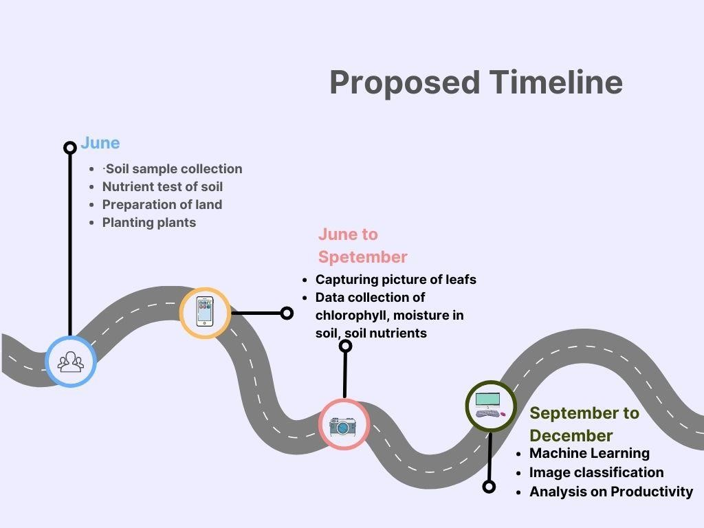

# THANK YOU